PRUEBA SABER 11
PARTE 3
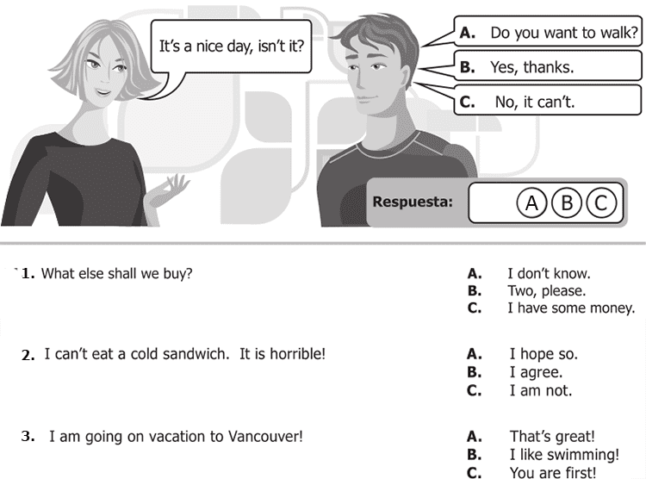

7. I can’t eat a cold sandwich. It is horrible! A. I hope so
B. I agree
C. I am not

8. I am going on vacation to Vancouver! A. That´s great!
B. I like swimming c
C. You are first

9. It rained a lot last night! A. Did you accept?
B. Did you understand?
C. Did you sleep?

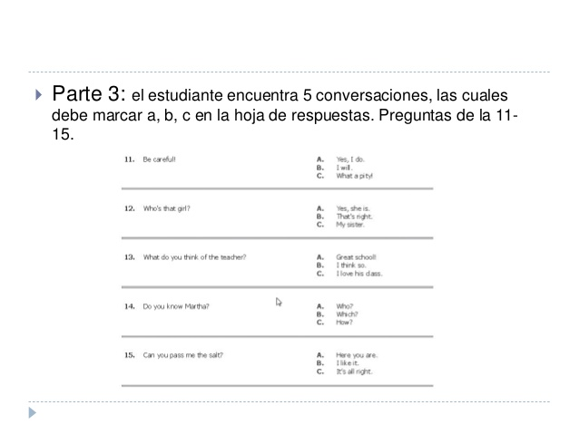
11. Be careful! A. Yes, I do.
B. I will.
C. What a pity!

12. Who’s that girl? A. Yes, she is.
B. That’s night.
C. My sister.

13. What do yo think of the teacher? A. Great school!
B. I think so.
C. I love his class.
14. Do you know Martha? A. Who?
B. Which?
C. How?

15. Can yo pass me the salt? A. Here you are.
B. I like it.
C. It’s all right.
